**Sunil Babu Peethambaram ** +1 (937) 838 2437

Data Scientist and Data Engineer  [sunilbabu@gmail.com](mailto:sunilbabu@gmail.com)

[*http://www.linkedin.com/in/sunil-babu-peethambaram-54a70854*](http://www.linkedin.com/in/sunil-babu-peethambaram-54a70854)

**Objective**

Looking to move towards Data Science experience at organizations that offer both a challenging as well as learning environment around concepts such as Big Data, Machine Learning, Artificial Intelligence, Analytics and Visualization. Eager to take big strides in the Data world through learning and implementation of revolutionary concepts.

**Areas of Experience**

**Skillset**

**Domains**

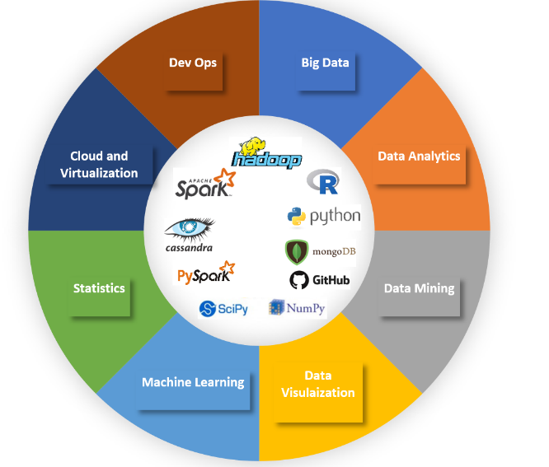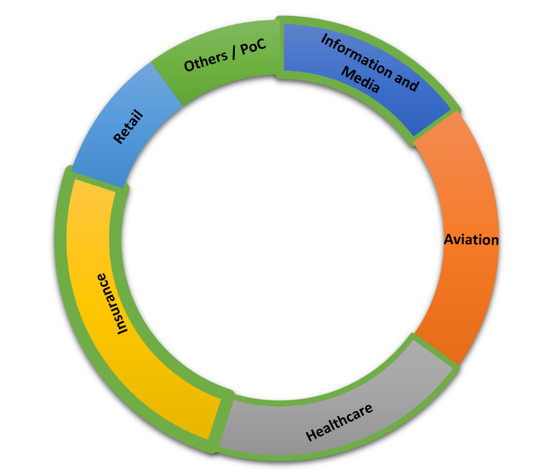

**Education**

**Bachelor of Engineering in Computer Science & Engineering**  May 2003

University of Madras, India

**Professional Profile**

Around 15 years of experience with various domains and various clients. Currently into the Data Analytics space with heavy work involved in Big Data. Aiming to become a Data Scientist through sheer experience. Have worked in challenging and interesting projects and took them to successful implementation.

**Highlight:** Work in a Big Data project for a Aviation client where we migrated “Flight Connections” solution to generate 100 million connections in a span of 4 hours with more than 100k rules as part of the rule engine that was also created as part of the solution. The previous performance was 4 days and the current run time is within 4 hours. This was achieved by a 3 member team and I was one among the contributors.

**Professional Experience**

**Cognizant Technology Solutions. May 2012 to Present**

**Big Data Solution Architect / Project Manager**

**My Tech Stack**

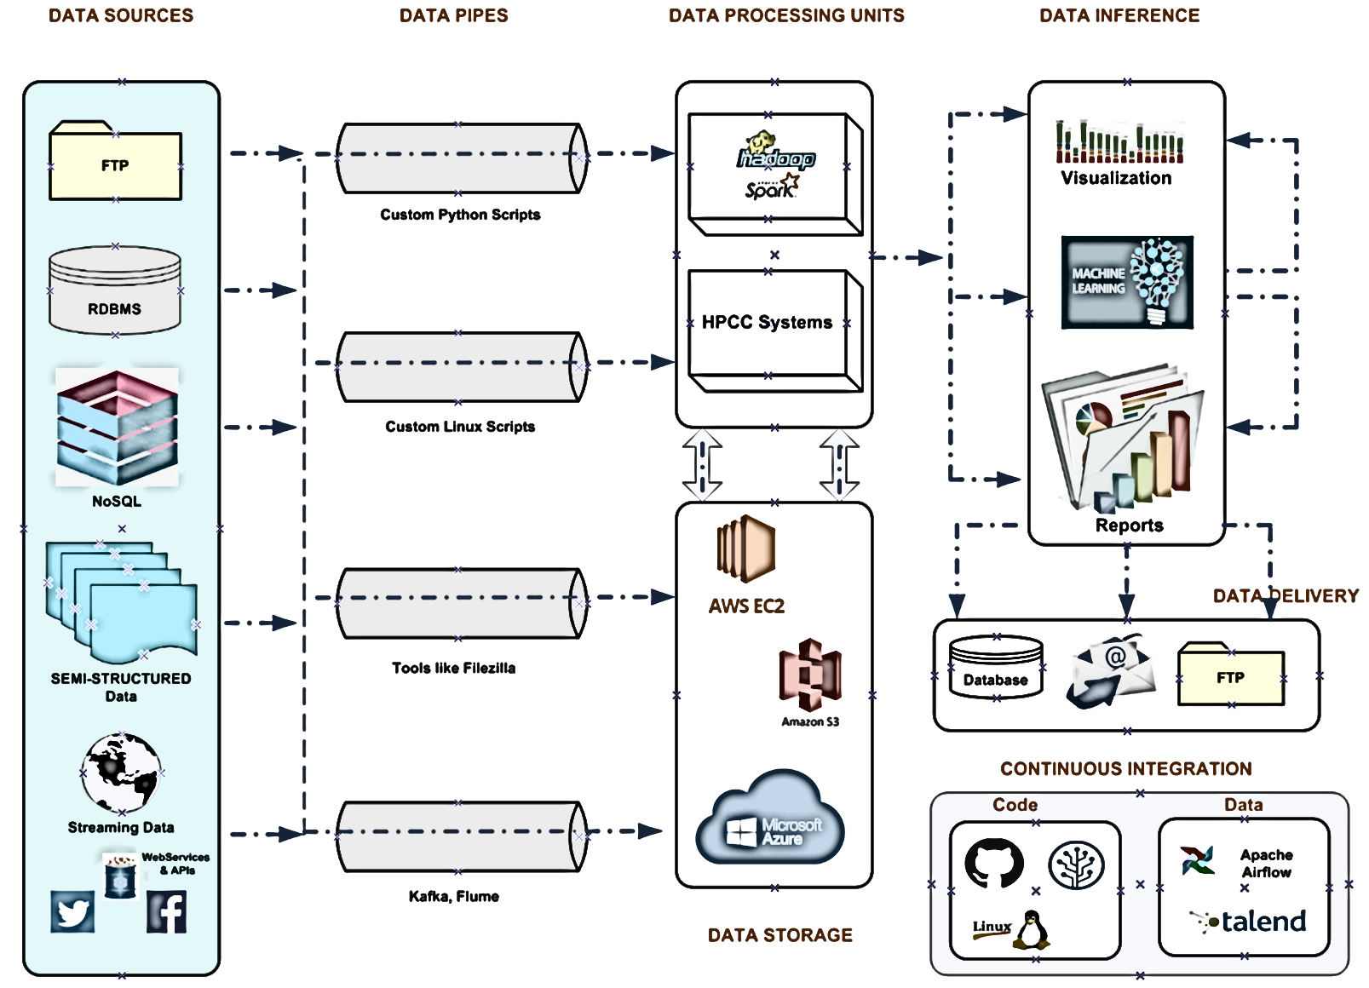

**Key Projects:**

* **Big Data migration for a Aviation Client :**

**Client: FlightGlobal**

**Location: Alpharetta, USA**

Flightglobal, an Aviation wing of RBI (Reed Business Information), aquired Innovata in early 2015 and the solution then for creating Flight connections was done through SQL server that took a painful 4 days to create 100 million connections. The connections thus created was already 4 days old and the next file that would get processed will again be 4 days old. Our team of 3 Big Data Engineers took it upon ourselves to implement this solution in a Big Data Environment where the whole solution was rewritten from scratch with all existing imperfections being solved in the new version. Result, a robust solution that runs only for 4 hours and a brilliant way such that a breakdown on the job will need the re-run to start from where it broke.

* **Geolocation and Author Identification (R&D):**

**Client: Reed Elsevier**

**Location: Dayton, USA**

A list of journals that did not have an author name needed to be identified with the Author with basic info such as place of publishing of the journal , the department, university , publication address, topics, subject of interest and an already resolved set of Author-Journal file were given as inputs and through some machine learning algorithms, had to identify the appropriate author for those journals. A very interesting project that pushed my interest towards Machine Learning.

* **Sharecare Automation of ETL (Onsite):**

**Client: LN Risk Solutions**

**Location: Alpharetta, USA**

Sharecare, a Healthcare organization had different data sources providing data on Healthcare. These data from different data sources needed to go through ETL processing and pipelined to a standard format to be published back to Healthcare for their processing. The whole process needed to be automated so that any additional data sources should simply fall in line without much of a manual intervention.

* **BrandEye (Offshore)**:

**Client: Cognizant Internal**

**Location: Chennai, India**

As a senior developer, I participated in the design discussion for the POC and was involved in developing the application with a team of 2-3 members. I was involved in tasks such as getting the twitter data from Data sift (3rd party vendor) by running a CSDL query and direct the data to amazon S3. Convert the data from Json to XML using available java files.

* **Sentiment Analysis – Emotions (Offshore)**:

**Client: Cognizant Internal**

**Location: Chennai, India**

Classify tweets based on different emotions/sentiments using naïve bayes algorithm. Developed this as a part of reusable component and used in PRNewsWire POC and other scenarios.

* **PRNews (Offshore)**:

**Client: PRNewsWire**

**Location: Chennai, India**

As a developer, I was involved in developing the index search functionality from a 40GB size of news and blog data. Performed various text analysis such as Entity extraction, Sentiment analysis, keyword extraction and Concept tagging using Alchemy API’s. The API’s were invoked as rest service. Tested the application end to end for various strings patterns and optimized the code performance. I was also involved in the hardware setup like spinning a AWS machine/cluster.

**HCL Technologies**  **Apr 2011 to Aug 2012**

Associate Project Manager

**Key Projects:**

* Worked as a Technical Lead for Warehouse Management System Development team for the client Pfizer
* Delivered enhancements in WMS module and took the team through the transition phase. Provided stability and kept the project deliveries on time.
* Managed the Build and Release team for a UK client Skandia. Helped the team to achieve its potential by effectively managing the resources and bringing an orderliness to the way releases were handled.

**CSC**  **Jun 2010 to Apr 2011**

Application Lead

**Key Projects:**

* Worked as a Technical Lead for Warehouse Management System Development team for the client Pfizer
* Worked as a Technical Development Lead for Order Management System
* Worked as a Development resource for designing Barcode (Shipment and BoL) labels. Was the only resource with the knowledge of working the labels designing using an AS400 application.

**Infosys Technologies**  **Sept 2003 to Jun 2010**

Technical Analyst

**Key Projects:**

* Worked as a Technical Lead for Store Operations (PoS , Adjancency using RF systems and Quick Orders) at Walgreens (2010) Chicago
* Worked as a Technical Lead for Item Exit and Markdowns for the Merchandise at Walgreens (2009), Chicago
* Worked as a MDM specialist for Data team at Starbucks, Seattle (2009)
* Worked as a Quality Assurance Engineer at Starbucks, Seattle (2008)
* Worked as a Application lead for Kraft Foods, Montreal (2007)
* Worked as Development lead for Item Exit, Markdown and Logistics teams at Walgreens (2005 – 2007)
* Worked as Development Engineer for Toys R Us , Chennai (2004)
* Trainee - 2003

**Certifications / Trainings:** MongoDB Course from 10gen, R programming from Coursera, Machine Learning in Coursera, Azure HDInsight, Data Science Courses from Edx etc.